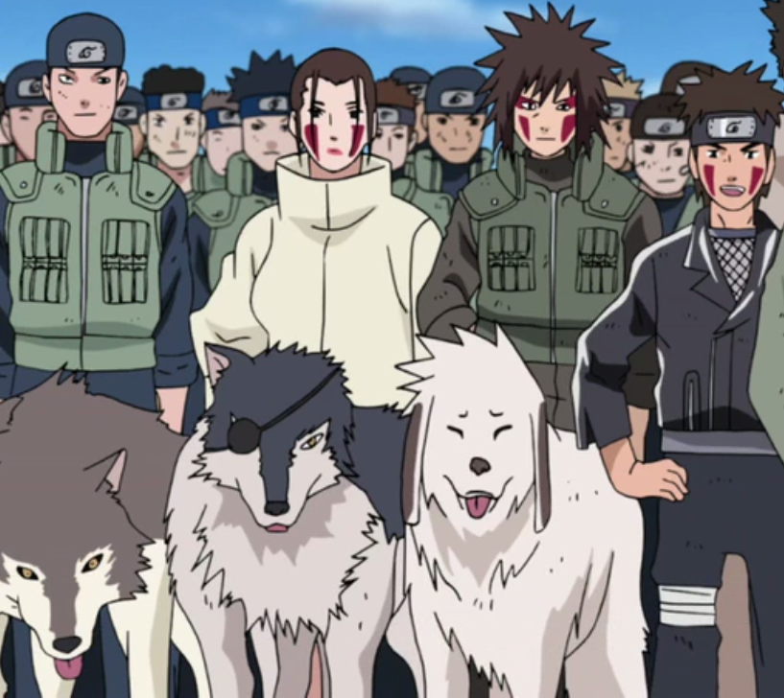

**Inuzuka Clan**

The Inuzuka (犬塚一族, Inuzuka Ichizoku) are one of the three clans residing in Watashitachi wa, Ataryoshi. They are known for their canine like mien and their ability to converse with and use ninja-dog in combat, referred to as Ninken. They are known to be capable hunters and trackers, even enjoying both activities.

History

**Preface**

The Inuzuka in linage are the clan most closely coupled with the beast of ole. Unlike the All-Beast, the beast they spring from was already anthropomorphic. Yenaldooshi, was the name of this beast who walked on two legs. It was said to have to power to commune with canine and cause them to become rabid and attack other animals and even their animals. This beast was often mistaken for the All-Beast due to it having human like features of walking upright and even being able to commune in the human tongue. Overtime the beast grew weaker, and a clan of radicals who mistook the beast for the All-Beast in it’s old age killed and consumed it’s flesh. It being said those that consume the flesh of the All-Beast gain unfathomable power. Although the Yenaldooshi did not hold a light to the All-Beast, those who consumed his flesh gained canine like abilities. Their teeth grew sharper as well as their nails, their sense had been enhanced ten-fold, and they gained the ability to commune with the local wildlife. They were shunned by other humans until Asahi of the First Flame came and took them in, giving them a home and a purpose.

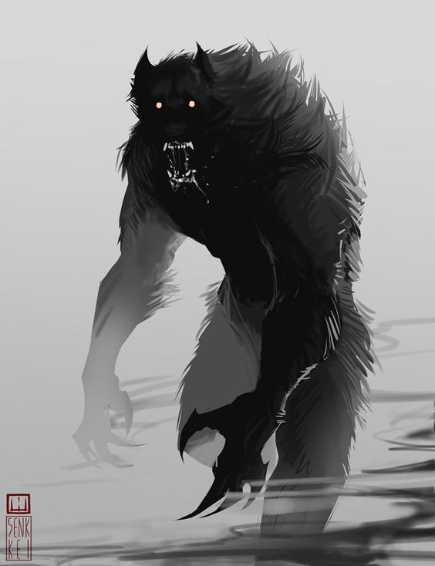  
 **The Yenaldooshi**

**Current**

The Inuzuka are extremely loyal to Ataryoshi and are currently doing all they can to bring it into power. They are prized by both the Fuma and the Yotsuki for their various uses in battle. They are widely renown to house the most expert trackers and can track targets down for days by scent alone.

Description

The Inuzuka appear human with various canine like features, such as long nails and fangs, slit predatorial eyes, and mannerism more beast like than man. Their hair are various shades of brown and they often have more hair growth than that of a normal human.

Inuzuka have a more pack like mentality, having one person they deem the *Alpha* who is ultimately the leader of the Inuzuka. Their ways seem more instinctual than structured as they respond to a hierarchy of strength rather than reason. They are canine like in nature and enjoy things such as hunting.

Player Guide

*Inuzuka are one of the wildest clans known to date due to their strong linage to The Beast. They naturally crave chaos even when unnecessary and even with the militant structure of Ataryoshi are known to blatantly disobey orders for their own amusement. Although, they are more responsive to strength and are extremely loyal to those they deem their “Alpha”. Their ways verge from playful jests to macabre acts of savagery in the blink of an eye, they are easily one of the hardest group of people to truly understand for those on the outside looking in.*

-Inuzuka often allow their hair to grow wildly and very rarely care for their appearance or hygiene.

-Inuzuka are known to be chaotic in nature, and often disturb peace from boredom.

-They enjoy giving chase and toying with those they call “Prey”. Known to torture them for hours on end for their own amusement.

-Inuzuka have very bare knowledge of Math, Science, English, and History. They are put through the Military School of Ataryoshi the lessons rarely ever stick.

- They are extremely loyal to their own clan and their Ninken, and treat their Ninken with the respect and love of anyone else in their clan.

-The Inuzuka are fiercely loyal to the “Alpha” and this is the only person who seems to ever have full control over the Inuzuka.

-Inuzuka often grow out of their chaotic ways with age, the older they get the more reasonable they become. This is why the “Alpha” is usually an older Inuzuka, but younger ones have been able to display the maturity to become an “Alpha”.

-This is due to their brains working the same as canine, being wild and chaotic at youth but tend to mellow out with age.